Indian School Al Wadi Al Kabir
SAMPLE PAPER
COMPUTER SCIENCE (Code: 083)

Class : XII Time: 3 Hours
Max. Marks : 70

General Instructions:
- 1. This question paper contains five sections, Section A to E.
- All questions are compulsory.
- Section A have 18 questions carrying 01 mark each.
- Section B has 07 Very Short Answer type questions carrying 02 marks each.
- Section C has 05 Short Answer type questions carrying 03 marks each.
- Section D has 03 Long Answer type questions carrying 05 marks each.
- Section E has 02 questions carrying 04 marks each. One internal choice is given in Q35 against part c only.
- All programming questions are to be answered using Python Language only.

Qn No. | SECTION A | Marks  Allocated
1 | State True or False  “A library in Python is a collection of various packages.” | 1
2 | Which of the following is a mutable datatype in Python?  (a) int (b) string (c) list (d) tuple | 1
3 | What will be displayed by the following code:  D={10:100 , 20:200, 30:300,40:400}  print(100 in D, D.get(30))  a. False 300  b. True 300  c. False 30  d. True 30 | 1
4 | If all devices are connected to a central hub, then topology is called  a)tree topology b)bus topology c)star topology d)mesh topology | 1
5 | The files that consists of human readable characters  (a) binary file  (b) text file  (c) Both (a) and (b)  (d) None of these | 1
6 | Which of the following mode in file opening statement is used to update the records in a file?  (a) a+ (b) r+ (c) w+ (d) None of the above | 1
7 | Fill in the blank:  command is used to add a column to a table in SQL.  (a) update (b)add (c) alter (d)insert | 1
8 | Which of the following will result in an error?  str1=“hello”  (a) print(str1[1])  (b) str1[2]=“a”  (c) print(str1[0:7])  (d) Both (b) and (c) | 1
9 | Fill in the blank:  Candidate keys – alternate keys = __________________  - Primary Key  - Foreign Key  - Unique Key  (d) Different Key | 1
10 | To write data into CSV from python console, which of the following function is  correct?  a) csv.write(file) b) csv.writer(file)  c) csv.Write(file) d) csv.writerow() | 1
11 | Which of the following is not a DDL command?  a) UPDATE b) TRUNCATE c) ALTER d) None of the Mentioned | 1
12 | Every network interface card(NIC) comes with its own….. address.  - Internet protocol  - DHCP  - MAC  - OSI | 1
13 | Evaluate the following:  16 // 3 + 3 ** 3 + 15 / 4 - 9  a. 27.75 b. 26.75 c. 30 d. 29.0 | 1
14 | The RDBMS terminology for a row is  (a) Tuple (b) relation (c) attribute (d) degree | 1
15 | To reflect the changes made in the database permanently you need to run ________  a)done()  b)reflect()  c)commit()  d)final | 1
16 | To execute all the rows from a result set, which method is used?  a. fetch all() b. fetchmany() c. fetchone(0 d. None of these | 1
Q17 and 18 are ASSERTION AND REASONING based questions. Mark the correct choice as
(a) Both A and R are true and R is the correct explanation for A
- Both A and R are true and R is not the correct explanation for A
- A is True but R is False
- A is false but R is True

17 | Assertion (A):- Local Variables are accessible only within a function or block in which it is declared.  Reasoning (R):- Global variables are accessible in the whole program. | 1
18 | Assertion(A): Python overwrites an existing file or creates a non-existing file  when we open a file with ‘w’ mode .  Reason(R) : a+ mode is used only for write operations | 1
 | SECTION B
19 | Sona has written the following code to check whether number is divisible by  3 .She could not run the code successfully. Rewrite the code and underline  each correction done in the code.  x=10  for I range in (a)  If i%3=0:  print(I)  else  pass | 4
20 | Differenciate between FTP and HTTP.  OR  What is the difference between LAN and WAN? | 2
21 | What is the difference between email and chat?  Or  What is web hosting? | 2
22 | Give the difference between text file and binary file. | 2
23 | (a) Expand the following terms:  i) MAN ii) HTML  b) What is URL ? | 2
24 | What possible output(s) are expected to be displayed on screen at the time of execution of the following code? Also specify the maximum and minimum value that can be assigned to variable X.  import random  L=[10,7,21]  X=random.randint(1,2)  for i in range(X):  Y=random.randint(1,X)  print(L[Y],"$",end=" ")  (i)10 $ 7 $ (ii) 21 $ 7 $ (iii) 21 $ 10 $ (iv) 7 $  OR  Predict the output of the Python code given below:  def div(lst,n):  for i in range(0,n):  if lst[i]%5==0:  lst[i]+=5  else:  lst[i]=lst[i]//2  lt=[45,20,23,54,5]  div(lt, len(lt))  for i in lt:  print(i,end='#') | 2
25 | Differentiate between alter and update statements in SQL  OR  What is the difference between char and varchar datatype in SQL? | 2
SECTION C
26 | i) Observe the following tables, EMPLOYEES and DEPARTMENT carefully and answer the question that follow :  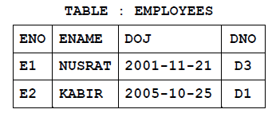  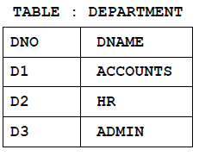  What will be the cardinality and degree of the cartesian product of the above two tables?  ii) Write an output for SQL queries (i) to (iii), which are based on the tables given below:  Table : STUDENT  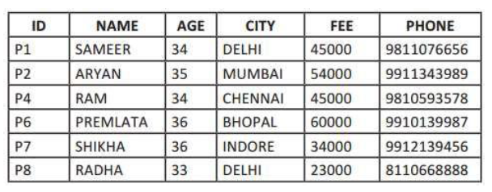  i) SELECT COUNT(*), City FROM STUDENT GROUP BY CITY HAVING  COUNT(*)>1;  (ii) SELECT MAX(FEE),MIN(FEE) FROM STUDENT;  (iii) SELECT NAME, AGE FROM STUDENT WHERE CITY=”Delhi”;  (iv). SELECT NAME,CITY FROM STUDENT WHERE NAME LIKE “_A%”  ORDER BY NAME; | 1+2
27 | Write a Python program to count all the line having 'a' as last character  OR  Write a function in Python that counts the number of “the” or “this” words  present in a text file “myfile.txt”.  Example  If the “myfile.txt” contents are as follows:  This is my first class on Computer Science. File handling is the easiest topic for me and Computer Networking is the most interesting one.  The output of the function should be: Count of the/this in file: 3 | 3
28 | a. Write SQL commands for the queries (i) to (iii) and output for (iv) & (v) based  on a table COMPANY and CUSTOMER .  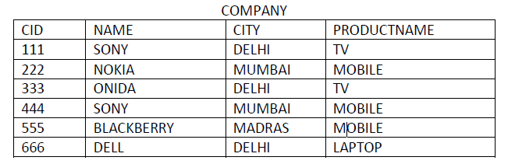  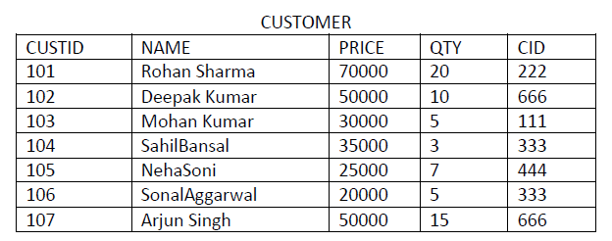  (i) SELECT PRODUCTNAME,CITY, PRICE FROM COMPANY,CUSTOMER  WHERE COMPANY.CID=CUSTOMER.CID AND  PRODUCTNAME=”MOBILE”;  (ii) SELECT AVG(QTY) FROM CUSTOMER WHERE NAME LIKE “%r%;  (iii) SELECT PRODUCTNAME, C2. NAME FROM COMPANY C1,  CUSTOMER C2 WHERE C1.CID = C2.CID AND PRICE <30000;  (iv) SELECT CID ,COUNT(*) FROM CUSTOMER GROUP BY CID;  b. Write a command to display the structure of the customet table | 2+1
29 | Write a function LMove(Lst,n) in Python, which accepts a list Lst of numbers and n is a numeric value by which all elements of the list are shifted to left.  Sample Input Data of the list  Lst= [ 10,20,30,40,12,11], n=2  Output Lst = [30,40,12,11,10,20] | 3
30 | Write a function in Python Push (nums), where nums is a list of numbers.From this list push all odd numbers into a stack implemented by using a list. Display the stack if it has at least one element, otherwise display appropriate error message.  OR  Write a function in Python Popstack (names), where names is a stack implemented by a list of names. The function returns the name deleted from the stack. A list contains following record of a customer: [Customer_name, Phone_number, City] | 3
SECTION D
31 | ABC CONSULTANTS is a professional consultancy company. The company is  planning to set up new offices in India with its hub at Gurugram. As a network  adviser, you have to understand their requirements and suggest to them the  best available solutions.  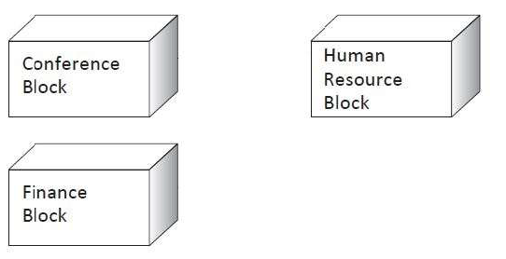  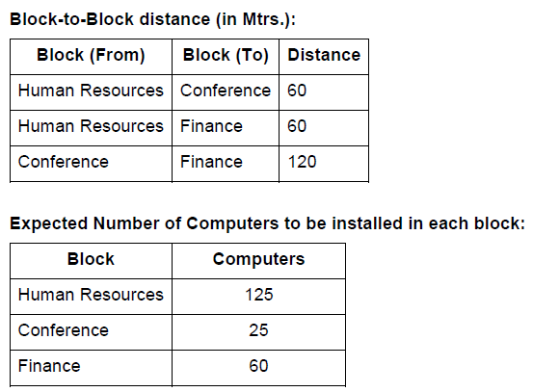  (a) What will be the most appropriate block where organization should plan to  install their server?  (b) Draw a block-to-block cable layout to connect all the buildings in the most  appropriate manner for efficient communication.  (c) What will be the best possible connectivity out of the following to connect  the new set-up of offices in Dehradun with its London base office?  (i) Infrared (ii) Satellite Link (iii) Ethernet Cable  (d) Which of the following devices will you suggest to connect each computer  in each of the above buildings?  (i) Gateway (ii) Switch (iii) Modem | 1  1  1  1
32 | - Write the output of the code given below:  total=0  def add(a,b):  global total  total=a+b  print(total)  add(6,6)  print(total)  b) The code given below inserts the following record in the table employee:  empno – integer Name – string dept – integer salary – integer  Note the following to establish connectivity between Python and MYSQL:  • Username is root  • Password is mysql  • The table exists in a MYSQL database named company.  • The details are to be accepted from the user.  Write the following missing statements to complete the code:  Statement 1 – to form the cursor object  Statement 2 – to execute the command that inserts the record in the table Student.  Statement 3- to add the record permanently in the database  import mysql.connector as mysql  def sql_data():  con1=mysql.connect(host="localhost",user="root",  password="msql", database="company")  mycursor= #Statement 1 eno=int(input("Enter emp number :: ")) name=input("Enter name :: ") dept=int(input("Enter dept :: ")) salary=int(input("Enter Marks :: ")) querry="insert into student  values({},'{}',{},{})".format(eno,name,dept,salary)  ______________ #Statement 2  _______________ # Statement 3  print("Data Added successfully")  OR  (a) Predict the output of the code given below:  def disp(str):  m=' '  for i in range(0,len(str)):  if(str[i].isupper()):  m=m+str[i].lower()  elif str[i].islower():  m=m+str[i].upper()  else:  if i%2==0:  m=m+str[i-1]  else:  m=m+"@"  print(m.swapcase())  disp('StudyBag$2021')  (b) Write a user defined function to read the records from the table named employee and displays only those records who have salary greater than 7500:  empno – integer Name – string dept – integer salary – integer  Note the following to establish connectivity between Python and MYSQL:  • Username is root  • Password is tiger  • The table exists in a MYSQL database named company. | 3
33 | Describe the various modes of opening a binary file?  Write a Program in Python that defines and calls the following user defined functions:  - ADD() – To accept and add data of a student to a CSV file ‘student.csv’. Each record consists of a list with field elements as rollno, name and mark  - COUNTR() – To count the number of students who scored more than 80 marks present in the CSV file named ‘student.csv’.  OR  Give any one point of difference between a binary file and a csv file.  Write a Program in Python that defines and calls the following user defined functions:  - add() – To accept and add data of an item to a CSV file ‘stock.csv’. Each record consists of a list with field elements as id, itname and price .  (ii) search()- To display the records of the items whose price is  less than 10000. | 5
SECTION E
34 | Write the output of the SQL queries (a) to (d) based on the table TRAVEL  given below :  Table : TRAVEL  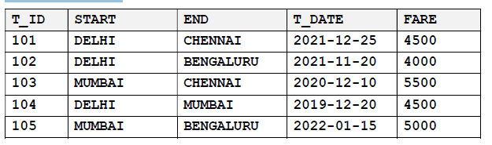  1. What is the suitable datatype of the column START  2. What is the cardinaity and degree of the table?  3. Write the statements to :  a. Delete the details of train from Mumbai to chennai.  b. Increase the fare of all Delhi train by 500.  OR  3. Write thestatement to:  a. Delete the columnt_date.  b. Insert a following record  ( 106, “ CHENNAI”, “MUMBAI”, 2022-09-23”, 5000) | 5
35 | A binary file “flight.dat” has structure [flightNo, source, Destination, fare].  Write a program to define the following fuctions and invoke them  i. Createfile () to input data for a record and add to flight.dat .  ii.CountCity(source) in Python which accepts the start city as parameter, find the total fare and return the total fare of the given sourceCity which are stored in the binary file “flight.dat”. | 5

********************************************************

